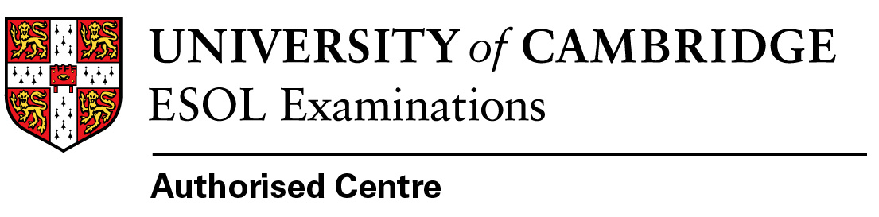
Please fill in the form electronicaly and return by
2 May 2023 by email to exams@balticcouncil.org
Exam | Exam date | Registration deadline |  | Fee EUR | Tick which exam you want to regsiter ✓
STEP 2 | 8 June 2023 | 2/05/23 |  | 200
STEP 3 | 21 June 2023 | 2/05/23 |  | 200
Please fill in all fields below:
Name and Surname
Date of Birth
UCAS registration number
Name of University where you apply
College where you apply
Course name & number
Home address
Phone number
E-mail address
Do you have any special needs (health problems)? |  |  | Yes No
Date of application
Bank details:
Account holder: Baltic Council for International Education
Registration Nr: 40008085919
Account numbers: LV20HABA0551019935194
Bank name: SWEDBANK HABA LV 22
Payer info: Admissions test +Your name & Surname + STEP 2023

